**Phoenixgreens School of learning**

**Grade: X**

**Subject: Mathematics**

**Worksheet on Real Numbers**

1. The product of the HCF and LCM of the smallest prime number and the smallest composite number is.___.
2. Find the LCM of smallest prime and smallest odd composite natural number.
3. Find the value of (-1)n + (-1)8n , where n is any positive odd integer.
4. Find the value of: (-1)n  + (-1)2n+1 + (-1)4n+2 , where n is any positive odd integer.
5. The LCM of two numbers is 10 times their HCF. The sum of LCM and HCF is 495. If one number is 90, then find the other number.
6. Use Euclid’s Algorithm to find the HCF of 858 and 325. Express it in the form x.858 + y.325.
7. Prove that  is an irrational number.
8. Show that  is an irrational number.
9. A class of 20 boys and 15 girls is divided into ‘n’ groups so that each group has ‘x’ boys and ‘y’ girls. Find x, y and n.
10. The HCF and LCM of two numbers are 33 and 264 respectively. When the first number is completely divided by 2, the quotient is 33. Find the other number.
11. The areas of three fields are 165 *m2*, 195 *m2* and 285 *m2* respectively. From these, flowers beds of equal size are to be made. If the breadth of each bed be 3 metres, what will be the maximum length of each bed?
12. Show that the square of any positive odd integer is of the form 8m+1, for some integer m.
13. Establish the linear combination between ‘a’ and ‘b’ using a = 1650, b = 847.
14. Find the smallest length of a rope which can be measured in exact number of times by three tapes measuring 1 *m* 20 *cm*, 75 *cm* and 1 *m* respectively.
15. Six bells commence tolling together at an interval of 2, 4, 6, 8, 10, 12 minutes respectively. In 30 hours, how many times do they toll together?
16. A rectangular courtyard is 18 *m* 72 *cm* long and 13 *m* 20 *cm* broad. It is to be paved with square tiles of the same size. Find the least possible number of such tiles.
17. The HCF of 2472, 1284 and a third number N is 12. If their LCM is 23 x 32 x 5 103 x 107. Then find the number N.
18. If A = 2n + 13 and B = n + 7, where n is a natural number then find HCF of A and B.
19. Find the largest four-digits number which when divided by 4, 7 and 13 leaves a remainder 3 in each case.
20. Find the least number which should be added to 2497 so that the sum is exactly divisible by 5, 6, 4 and 3.
21. Find the greatest number that will divide 43, 91 and 183 so as to leave the same remainder in each case.
22. Find the least number which when divided by 20, 25, 35 and 40 leaves remainders 14, 19, 29 and 34 respectively.
23. If least prime factor of ‘a’ is 5 and least prime factor of ‘b’ is 13, then what is the least prime factor of a + b?
24. The greatest number that will divide 76, 112, 172 and 184 so as to leave remainder 40 in each case is k2 x 3. Find the value of k.
25. A number 10x + y is multiplied by another number 10a + b and the result comes as 100p + 10q + r, where r = 2y, q = 2(x + Y) and p = 2x; y = 5, q ≠ 0. The value of 10a + b may be_________.
26. Two numbers are in the ratio 21 : 17. If their HCF is 5, find the numbers.
27. The HCF of two numbers is 29 and other two factors of their LCM are 16 and 19. Find the largest of the two numbers.
28. Three numbers are in the ratio 2 : 5 : 7. Their LCM is 490. Find the square root of the largest number.
29. Find the LCM of 2.5, 0.5 and 0.175.
30. Two natural numbers whose difference is 66 and the least common multiple is 360, then the two numbers are___________.
31. A positive integer ‘p’ when divided by 11 gives 6 as remainder. What will be the remainder when 4p + 5 is divided by 11?
32. An electronic device makes a beep after every 60 seconds. Another device makes a beep after every 62 seconds. They beeped together at 10 a.m. At what time will they beep together at the earliest?
33. The traffic lights at three different road crossing change after every 48 seconds, 72 seconds and 108 seconds respectively. If they all change simultaneously at 8 a.m. then at what time will they again change simultaneously?
34. The ratio between the LCM and HCF of 5, 15, 20 is ________.
35. P is prime and Q is a positive integer such that P + Q = 1696. If P and Q are co-prime and their LCM is 21879, then find P and Q.
36. P is the LCM of 2, 4, 6, 8, 10; Q is the LCM of 1, 3, 5, 7, 9 and L is LCM of P and Q. Evaluate L – 21P.
37. Show that the cube of any positive integer is of the form 4m, 4m + 1 or 4m + 3, for some integer m.
38. Find the smallest number which when divided by 17, 23 and 29 leaves a remainder 11 in each case.

**Worksheet on Polynomials ____________________________________________________________________**

1. If  are the zeros of x2 + 5x + 5, find the value of 
2. If are the zeros of the polynomial f(x) = 3x2 + 2x + p and  = , then find the value of p.
3. If are the zeros of the polynomial f(x) = 2x2 + 3x - 5, then find the value of ()2
4. If are the zeros of the polynomial f(x) = x2 + px + q, then find the polynomial having  and  as its zeros.
5. If are the zeros of the polynomial x2 + 5x +4, then find the value of  +  -2.
6. If  are the zeroes of cubic polynomial kx3 - 5x + 9. If 27, find the value of k.
7. If   are the zeros of the cubic polynomial x3 + 4x + 2, then find the value of  .
8. If the sum of squares of the zeros of the quadratic polynomial f(x) = x2 - 8x + k is 34, then find the value of k.
9. If are zeros of the polynomial x2 – 6x + a. Find the value of a, if 3 = 20.
10. Ifare the roots of the polynomial p(x) = x2 - (k + 6)x +2(2k - 1). Find the value of k, if 
11. If one zero of the polynomial ax2 + bx + c is double the other, prove that 2b2 = 9ac.
12. If are zeros of cubic polynomial x3 + px2 + qx + 2 such that  + 1 = 0. Find the value of 2p + q + 5.
13. If  and  are the zeros of the polynomial kx2 + 4x + 4 and ()2 - 2 = 24, then find the value of k.
14. If one zero of the polynomial p(x) = (a2 +9)x2 + 45x + 6a is reciprocal of the other, find the value of a.
15. Find the zeros of the polynomial f(x) = x3 – 5x2 -1x + 80, if its two zeros are equal in magnitude but opposite in sign.
16. If one zero of the polynomial (K + 1)x2 – 5x + 5 is multiplicative inverse of the other, then find the zeroes of kx2 – 3kx + 9, where k is constant.
17. If sum of the zeroes of the polynomial 5x2 – (3 + k) x + 7 is zero, then find the zeros of the polynomial 2x2 – 2(K + 11)x + 30.
18. If the product of the zeroes of the polynomial kx2 + 41x + 42 is 7 then find the zeroes of the polynomial (k – 4)x2 + (k + 1)x + 5.
19. If  are the zeroes of cubic polynomial x3 – 12x2 + 44x + c if  = , find the value of c.
20. If are zeroes of cubic polynomial x3 – 2x2 + qx – r. If  = 0 then show that 2q = r.
21. If the zeroes of x2 – px + 6 are in the ratio 2 : 3, find p.
22. If  are the zeroes of polynomial p(x) = x2 – k(x + 1) – p such that ( + 1)( + 1) = 0, find p.
23. a, b, c are co-prime a ≠ 1 such that 2b = a + c. If ax2 – 2bx + c and 2x3 – 5x2 + kx + 4 has one integral root common, then find the value of k.
24. If m, n are zeroes of ax2 – 5x + c. Find the value of ‘a’ and ‘c’ if m + n = m.n = 10.
25. If  be zeroes of polynomial 6x3 + 3x2 – 5x + 1, then find the value of If -1 +  -1 + -1.
26. Find the zeroes of the polynomial p(x) = x3 – 5x2 – 2x + 24, if it is given that the product of its zeroes is 12.
27. Find the zeroes of the polynomial 2x3 + 5x2 – 9x – 18, if it is given that the product of its two zeroes is -3.
28. If one of the zeroes of the cubic polynomial x3 + ax2 + bx + c is -1, then prove that the product of the two zeroes is b – a +1.

**Worksheet on Pair of Linear Equations in Two Variable**

**____________________________________________________________________**

1. Solve the following systems of linear equations: a(x + y) + b(x – y) = a2 + b2 – ab & a(x + y) – b(x – y) = a2 + b2 + ab
2. Solve for x, y and z from the following question: x + y = 4, y + z = 1 and z + x = 1.
3. Ratio between the girls and boys in a class of 40 students is 2 : 3. Five new students joined the class. How many of them must be boys so that the ratio between girls and boys become 4 : 5?
4. Draw the graphs of the equations: x = 3, y = 5 and 2x – y + 4 = 0. Also find the area of thequadrilateral formed by the lines and x-axis.
5. In a deer park, the number of heads and the number of legs of deer and human visitors were counted and it was found that there were 39 heads and 132 legs. Find the number of deer and human visitors in the park.
6. Two candles of equal height but different thickness are lighted. The first burns off in 6 hours and the second in 8 hours. How long, after lighting both, will the first candle be half the height of the second?
7. A villager went to a hotel in a town with his big family. They consumed 23 idlies, 18 pooris, 7 dosas and 19 vadas. The bill came to them was Rs. 108. On next day, they consumed 34 idlies, 22 pooris, 7 dosas and 8 vadas. The bill came to them was Rs. 114. If one idli costs the same as a vada, what is the cost of one poori?
8. The age of father is equal to the sum of ages of his 6 children. After 15 years, twice the age of the father will be the sum of the ages of his children. Find the age of father.
9. If from twice the greater of two positive numbers 16 is subtracted, the result is half the other number. If from half the greater number 1 is subtracted, the result is still half the other number. What are the numbers?
10. The sum of a two digit number and the number formed by interchanging its digits is 110. If 10 is subtracted from the first number, the new number is 4 more than 5 times the sum of the digits in the first number. Find the first number.
11. A lab assistant has a solution of 50% acid and other has 25% acid. How much of each should be mixed to make 10 litres of a 40% acid solution?
12. In a bag containing only white and black balls, half the number of white balls is equal to one third of the number of black balls. Also, two times the total number of balls exceeds three times the number of black balls, by 4. Find the number of balls of each type in the bag.
13. A man sold a chair and a table together for Rs. 1520 thereby making profit of 25% on chair and 10% on table. By selling them together for Rs. 1535 he would have made a profit of 10% on the chair and 25% on the table. Find the cost price of each.
14. There are two class rooms A and B. If 10 students are sent from A to B, the number of students in each room becomes the same. If 20 students are sent from B to A, the number of students in A becomes double the number of students in B. Find the number of students in each class.
15. A two digit number is obtained by either multiplying sum of the digits by 8 and adding 1 or by multiplying the difference of the digits by 13 and adding 2. Find the number.
16. If the hypotenuse of a right angled triangle is 41 cm and the area of the triangle is 180 *sq.cm*, find the difference between the lengths of the legs of the triangle.
17. In a triangle, the sum of the two angles is equal to the third. If the difference between them is 500, determine the angles.
18. A number consists of three digits whose sum is 17. The middle one exceeds the sum of the other two by 1. If the digits are reserved, the number diminished by 396. Find the number?
19. The result of dividing a number of two digits by the number with the digits reversed is $\frac{7}{4}$. If the sum of the digits is 12, find the number.
20. The largest angle of a triangle is equal to the sum of the other angles. The smallest angle is $\frac{1}{4}$ of the largest angle. Find the angles of the triangle.
21. A father has 3 children with a gap of 2 years in every two consecutive children. The sum of present ages of children is half the present age of the father. 4 years before, the sum of ages of children was 1 year more than the one fourth of age of the father. Find the present ages of children and the father.
22. Consider a 2-digit number such that when its digits are reversed, the new number obtained is 6 more than 3 times the original number. Also, one digit is 5 times that of the other. Find the original number.
23. A three digit number is such that its digit at ten’s place is 1 more than the digit at hundred’s place. The sum of the digits is 13. The number obtained by reversing the digits can be obtained by multiplying the original number with 2 and subtracting 49 from this product. Find the original number.

**Worksheet on Quadratic Equations ___________________________________________________________________**

1. Solve the equation: 

2. Solve the equation:  + .

3. Solve the equation: 2x – 3 = .

4. Solve the equation:  = 

5. Solve the equation: 2 - 3.

6. Solve for x: 3x+1 + 32x + 1 = 270.

7. Solve for x: x2/3 + x1/3 – 2 = 0.

8. Solve for x: x2 + 5x – (a2 + a – 6) = 0.

9. Solve the following quadratic equation: 9x2 – 9(a + b)x + [2a2 + 5ab + 2b2] = 0.

10. The sum of the squares of two consecutive multiples of 7 is 637. Find the multiples.

11. If twice the area of a smaller square is subtracted from the area of a larger square; the result is 14 *cm2*. However, if twice the area of the larger square is added to three times the area of the smaller square, the result is 203 *cm2*. Determine the sides of the two squares.

12. O girl! Out of a group of swans, 7/2 times the square root of the number is playing on the shore of a tank. The two remaining ones are playing with amorous fight, in the water. What is the total number of swans?

13. A teacher on attempting to arrange the students for mass drill in the form of a solid square found that 24 students were left over. When he increased the size of the square by one student he found that he was short of 25 students. Find the number of students.

14. There are three consecutive positive integers such that the sum of the squares of the first and the product of the other two is 154. What are the integers?

1. Three consecutive positive integers are such that the sum of the square of the first and the product of the other two is 46, find the integers.
2. By the reduction of Rs. 1 per *kg* in the sugar, Mohan can buy one *kg* sugar more for Rs. 56. Find the original price of sugar per kg.
3. If the roots of the equation (a-b)x2 + (b-c)x + (c-a) = 0 are equal, prove that 2a = b + c.
4. A two-digit number is such that the product of the digits is 12. When 36 is added to the number, the digits interchanged their places. Find the numbers.
5. If the ratio of the roots of the equation *lx2 + nx + n = 0 is p : q,* prove that  +  +  = 0.
6. Out of a number Saras birds, one fourth of the number are moving about in lotus; 1/9 th coupled(along) with ¼ th as well as 7 times the square root of the number move on a hill. 56 birds remain in Vakula trees. What is the total number of birds?
7. By selling an article for Rs. 24, a trader losses as much percent as the cost price of the article. Calculate the cost price.
8. If difference of the roots of the equation x2 – 7x = 2k = 0 is 1 then find the value of k.
9. The length of a verandah is 3 *m* more than its breadth. The numerical value of its area is equal to the numerical value of its perimeter.
10. The sum S of first n even natural numbers is given by the relation S = n(n+1). Find n, if the sum is 420.
11. Find three consecutive positive integers whose product is equal to sixteen times their sum.
12. Find the value of 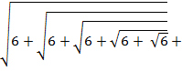 ……….
13. The hypotenuse of right triangle is 3 *cm*. If the smaller leg is tripled and the longer leg doubled, new hypotenuse will be 9 *cm*. How long are the legs of the triangle?
14. At present Asha’s age (in years) is 2 more than the square of her daughter Nisha’s age. When Nisha grows her mother’s present age, Asha’s age would be one year less than 10 times the present age of Nisha. Find the present age of both Asha and Nisha.
15. If x = , then find the value of  .
16. A ladder 10 feet long leans against a wall. The bottom of the ladder is 6 feet from the wall. The bottom of the ladder is then pulled out 3 feet farther. How much does the top end move down the wall?

**Worksheet on Arithmetic Progressions ____________________________________________________________________**

1. If the mth term of an AP be 1/n and its nth term be 1/m, then show that its (mn)th term is 1.

2. Sum of three numbers in AP is 21 and their product is 231. Find the numbers.

3. If a, b, c, d, e are in A.P, find the value of a – 4b + 6c – 4d + e.

4. The sum of the third and the seventh terms of an A.P. is 6 and their product is 8. Find the sum of first

sixteen terms of the AP.

5. If m times the mth term of an AP is equal to n times nth term then show that (m+n)th of AP is zero.

6. If pth, qth, rth terms of an AP be a, b, c respectively, then prove that, p(b-c) + q(c-a) + r(a-b) = 0.

7. If the pth term of an AP is 1/q and its qth term is 1/p, show that sum of its first pq terms is (pq + 1).

8. Find the sum of the following: + + +………Up to n terms.

9. In an AP of 50 terms, the sum of first 10 terms is 210 and the sum of its last 15 terms is 2565, Find the

AP.

10. If the roots of the equation (b – c) x2 + (c – a)x + (a – b)= 0 are equal, the show that a, b, c are in AP.

11. The sum of the first 7 terms of an AP is 63 and the sum of its next 7 terms is 161. Find the 28th term of

this AP.

12. Find the sum of the following series: 5 + (- 41) + 9 + (- 39) + 13 + (- 37) + 17 + ….. + (- 5) + 81 + (- 3)

13. If the sums of first n, 2n, 3n terms of an AP are , , respectively, show that = 3( - ).

14. If , , are the sums of the n terms of three series in AP, the first term of each being 1 and the respectively common difference being 1,2,3; prove that = 2

15. If the sum of ‘m’ terms of an AP to the sum on ‘n’ terms of the same A. P. is m2 : n2, prove that the ratio of its mth and nth terms is 2m -1 : 2n – 1.

16. An A.P consists of 37 terms. The sum of three middle most terms is 225 and the sum of the last

three is 429. Find the A.P.

17. The ratio of the 11th term to the 18th term of an A.P is 2:3. Find the ratio of the 5th term to 21st

term, and also the ratio of the sum of the first five terms to the sum of first 21 terms.

18. The sums of n terms of two arithmetic series is in the ratio of . Find the ratio of their 9 th terms.

19. The first, second and last terms of an A.P. are a, b and 2a respectively, show that its sum is .

20. If the first term, the last term and the sum of an A.P are a, and S respectively, show that the

common difference d = .

21. If = 7, find the value of n.

22. If a, b, c are in A.P., show that (a + 2b – c) (2b + c – a)(a + 2b + c) = 16abc.

23. A club consists of members whose ages are in AP the common difference being 3 months. If the

younger member of the club is just 7 years old and the sum of the ages of all the members is 250

years, find the number of members in the club.

24. Find the sum of all two digit natural numbers which when divided by 3 yields 1 as remainder.

25. The sum of first 16 terms of an A.P. is 120. Find second term of another A.P. whose first term is 2/15 times of first terms of given A.P. and common difference same as common difference of given A.P.

**Worksheet on Triangles**

**___________________________________________________________________**

1. In $∆$ ABC, P, Q are points on AB, AC respectively and PQ ∥ BC. Prove that the median bisects PQ.
2. AD is the median of $∆ABC,Ois$ any point on AD, BO and CO when produced meet AC at AB and E and F respectively. AD is produced to X such that OD = DX. Prove that: AO : AX = AF : AB and hence prove that EF // BC.
3. Any point X is taken on the side BC of a triangle ABC and XM, XN are drawn parallel to BA, CA, meeting CA, BA in M and N respectively. MN meets BC produced in T. Prove that: TX2 = TB x TC.
4. In trapezium ABCD. AB || DC and DC = 2 AB.EF is drawn parallel to AB cuts AD in F and BC in E such that BE/EC = ¾. Diagonal DB intersects FE at G. Prove that 7 FE = 10 AB.
5. ABCD is a parallelogram. P is a point on side BC and DP when produced meet AB at L. Prove that
6. DP/PL = DC/BL ii) DL/DP = AL/DC
7. P and Q are points on sides AB and AC respectively of $∆$ ABC. If AP = 3 cm, PB = 6 cm, AQ = 5 cm and QC = 10 cm, show that BC = 3 PQ.
8. The perimeter of two similar triangles is 30 cm and 20 cm respectively. If one side of the first triangle is 12 cm, determine the corresponding side of the other triangle.
9. The diagonal BD of a parallelogram ABCD intersects the segment AE at the point F, where E is any point on the side BC. Prove that DF x EF = FB x FA.
10. D is a point on the side BC of a triangle ABC such that ∠ADC = ∠BAC. Show that CA2 = CB x CD.
11. ABCD is a parallelogram; P is the mid-point of the side CD. BP meets diagonal AC at X. Prove that 3AX = 2 AC.
12. Two poles of height ‘a’ metres and ‘b’ meters are ‘p’ metres apart. Prove that the height of the point of intersection of the lines joining the top of each pole to the foot of the opposite pole is given by (ab)/(a+b) metres.

**Worksheet on Coordinate Geometry**

**___________________________________________________________________**

1. Find the equation of the perpendicular bisector of AB, where A and B are the points (3, 6) and (-3, 4)

respectively.

2) If the co-ordinates of the middle point of the line segment joining the points (2,1) and (-1,3) be ($α,β$, show

that 6 – 8 = 0.

3) Find the co-ordinates of a point P on Y-axis, equidistance from the two points A(-3, 4) and B(3, 6) on the

same plane.

4) Prove that the distance between (1, 2) and (3, 8) be double of the distance of (3, -1) from the origin.

5) If the distance of the points P from the point (3, 4) is $√10$ and abscissa of P is double its ordinate, find the

co-ordinate of P.

6) Find the centroid of the $∆$ ABC whose vertices are (6, -2), (4, -3) and (-1, -4).

7) The line joining the points (2, 1) and (5, -6) is bisected at P. Find the value of k, if P lies on the line 2x + 4y + k = 0.

8) The co-ordinate of the midpoint of the line joining the points (3p, 4) and (-2, 2q) are (5, p). Find the value of

p and q.

9) The vertices of a triangle are (6, 0),(0, 6) and (6, 6). Find the distance between its circumcentre and

centroid.

10) Find the lengths of the medians of the triangle whose vertices are (1, -1), (0, 4) and (-5, 3).

11) Find the centre of a circle passing through the points (6, -6), (3, -7) and (3, 3).

12) If two adjacent vertices of a parallelogram are (3, 2) and (-1, 0) and the diagonals intersect at (2, -5), then

find the coordinates of the other two vertices.

13) Is point A(2, 7) lies on the perpendicular bisector of line segment joining the points P(6, 5) and Q(0, -4)?

14) If P and Q are two points whose coordinates are (at2, 2at), (, and S is the point (a, 0). Prove that

$\frac{1}{SP}$**+ $\frac{1}{SQ}$**  is constant for all values of t.

**Worksheet on Trigonometry**

**_________________________________________________________________**

1) If sin – cos = 0, then value of is…….

2) If 2sin2 = , then value of is …………

3) If sin – cos=0 and 00< < 900, find the value of.

4) If cos + sin= cos, show that cos – sin= sin.

5) If a cos = c, prove that .

6) If 1 + sin2 = 3 sin cos, then prove that tan = 1 or .

7) Given that sin $θ$ + 2 cos $θ$ = 1, then prove that 2 sin – cos= 2.

8) If sinA = , verify that .

9) If sin = 1, prove that

10) Prove that: 2 sec2 – sec4 - 2 cosec2 + cose4 = cot4 - tan4

11) If cosec, then prove that cosec .

12) If then prove that q(p2 – 1) = 2p.

13) If tanA = n tanB and sinA = m sinB, prove that cos2A =

14) Prove that: = 2 +

15) If secA + tanA = P then prove that = sinA.

16) Prove that: (tan cot)2 = sec2 + cosec2

17) Prove that: ()2 + ()2  = 2()

18) Prove that: = 1

19) If tan and prove that .

20) If prove that .

21) If and prove that

22) If a cos3 + 3a cos sin2 = m, a sin3 + 3a cos2 sin = n, prove that (m + n)2/3 + (m- n)2/3 = 2a2/3.

23) If 4 sin = 3 and $\sqrt{\frac{{cosec}^{2}θ-\cot^{2}θ}{\sec^{2}θ-1}}$ + 2 cot $θ$ = $\frac{\sqrt{7}}{x}$ + cos, find value of .

24) If 7 sin2 + 3 cos2 = 4, then prove that sec + cosec = 2 +

25) If cosec – sin = a3 and sec – cos = b3, prove that a2b2 (a2 + b2) = 1.

26) If cosec $θ$– sin = a and sec $θ$– cos = b, prove that a2b2(a2 + b2 + 3) = 1.

27) Prove that sin8 – cos8 = (sin2 – cos2)(1- 2sin2cos2).

28) If tan2 = 1 + 2 tan2, prove that 2 sin2 = 1+ sin2.

29) If tan - cot = a and cos $θ+$ sin= b, show that (a2 + 4)(b2 – 1)2 = 4.

30) Prove that: (tan A – tan B)2 + (1 + tanA tanB)2 = sec2 A sec2 B

31) Prove that: + + + = 2

32) If cos + cos2 = 1, prove that sin12+3sin10+ 3sin8+sin6+2sin4+2sin2-2 = 1.

33) If tan + 1 = $\sqrt{2}$, then prove that cos $θ$– sin $θ$ = $\sqrt{2}sinθ$

**Worksheet on Application of Trigonometry**

**_________________________________________________________________**

1) A vertical tower stands on a horizontal plane and is surmounted by a vertical flagstaff of height h. At

a point on the plane, the angle of elevation of the bottom of the flagstaff is $α$ and that of the top of

the flagstaff is $β$. Prove that the height is .

2) There is a small island in the middle of a 100 *m* wide river and a tall tree stands on the island. P and Q are

points directly opposite each other on the two bank, and in line with the tree. If the angles of

elevation of the top of the tree from P and Q are respectively 300 and 450, find the height of the tree.

3) From the top of a light house, the angles of depression of two boats on the opposite side of it are

observed to be $α$ and $β$. If the height of the light house be ‘h’ metres and the line joining the boats

passes through the foot of the light-house, then show that the distance between the two boats is

.

4) From the top of a building 100 *m* high, the angles of depression of the top and bottom of a tower are

observed to be 450 and 600 respectively. Find the height of the tower. Also find the distance between

the foot of the building and bottom of the tower.

5) Two station due south of a leaning tower which leans towards the north arc at distances ‘a’ and ‘b’ form its

foot. If $α,$ $β$ be the elevations of the top of the tower from these stations, prove that its inclination $θ$ to the

horizontal is given by cot= .

6) A round balloon of radius ‘a’ subtends an angle $θ$ at the eye of the observer while the angle of elevation of

its centre is $∅$. Prove that the height of the centre of the balloon is a sin .

7) A man of height ‘a’ stands at a distance of ‘2a’ from a lamp-post and casts a shadow of ‘3a’ on the ground. Find the height of the lamp-post.

8) An aeroplane flying horizontal at a height of 1.5 *Km* above the ground is observed at a certain point on earth to subtend an angle of 600. After 15 seconds, its angle of elevation is observed to be 300. Calculate the speed of the aeroplane in km/h.

9) The angle of elevation of a cloud from a point h m above a lake is $α$ and the angle of depression of its reflection in the lake is $α$, prove that the distance of the cloud from the point of observation is .

10) The angle of elevation of a cloud from a point h metres above a lake is 0 and the angle of depression of its reflection in the lake is 0 prove that the height of the cloud is 2h.

11) From vertically situated aeroplane to the straight horizontal road, the angle of depression of two stones 1 km apart are $α$ and $β$. If an aeroplane is in vertical plane in between two stones, show that the height of the aeroplane from the road (in kilometres) will .

12) From the top of a tower 60 *m*. high, the angles of depression of the top and bottom of a building whose base is in the same straight line with the base of the tower are observed to be 300 and 600 respectively. Find the height of the building.

13) A window of a house is h metres above the ground. From the window, the angle of elevation and depression of the top and the bottom of another house situated on the opposite side of the lane are found $α$ and $β$, respectively. Prove that the height of the other house is h(1 + tan $α$ cot $β$) metres.

14) From a point on the ground, the angle of elevation of the top of a vertical tower is found to be such that its tangent is 3/5. On walking 50 *m* towards the tower, the tangent of the new angle of elevation of the top of the tower is found to be 4/5. Find the height of the tower.

15) A man in a boat rowing away from a light house 100 *m* high takes 2 minutes to change the angle of elevation of the top of the light house from 600 to 300. Find the speed of the boat in metres per minute. (use = 1.732)

16) A ladder rests against a vertical wall at an inclination $α$ to the horizontal. Its foot is pulled away from the wall through a distance $p$ so that its upper end slides a distance $q$ down the wall and then the ladder makes and angle $β$ to the horizontal. Show that.

17) The length of a string between a kite and a point on the roof of a building 10 *m* high is 180 *m*. If the string makes an angle $θ$ with the level ground such that tan $θ=\frac{3}{4}$, how high is the kite from the ground?

**Worksheet on Circles**

**__________________________________________________________________**

1. A circle touches the side BC of a ABC at appoint P and touches AB and AC when produced at Q and R respectively. Show that AQ = (Perimeter of ABC).
2. Given two concentric circles of radii a and b where a > b, find the length of a chord of larger circle which touches the other.
3. The radii of two concentric circles are 13 cm and 8 cm. AB is a diameter of the bigger circle. BD is a tangent to the smaller circle touching it at D. Find the length AD.
4. The in circle of ABC touches the sides BC, CA and AB at D, E and F respectively. Show that AF + BD + CE = AE + BF + CD = (Perimeter of ABC).

1. ABCD is a quadrilateral such that ∠*D* = 900. A circle C(O, r) touches the sides AB, BC, CD and DA at P, Q, R and S respectively. If BC = 38 cm, CD = 25 cm and BP = 27 cm, find r.
2. An isosceles triangle ABC is inscribed in a circle. If AB = AC = 13 cm and BC = 10 cm, find the radius of the circle.
3. Two tangents TP and TQ are drawn from a external point T to a circle with centre O, as shown in fig. If they are inclined to each other at an angle of 1000 then what is the value of <*POQ*?

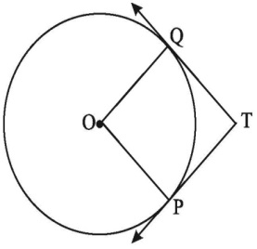

1. The in circle of ABC touches the sides BC, CA and AB at D, E and F respectively. If AB = AC, prove that BD = CD.
2. XP and XQ are tangents from X to the circle with O, R is a point on the circle and a tangent through R intersect XP and XQ at A and B respectively. Prove that XA + AR = XB + BR.
3. 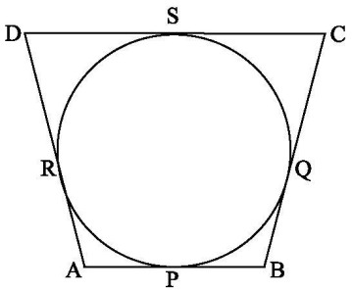 A circle touches all the four sides of a quadrilateral ABCD with AB = 6 cm, BC = 7cm and CD = 4 cm. Find AD.
4. TP and TQ are tangents to a circle with centre O at P and Q respectively. PQ = 8cm and radius of circle is 5 cm. Find TP and TQ.
5. In the below figure PT is tangent to a circle with centre O, PT = 36 cm, AP = 24 cm. Find the radius of the circle.

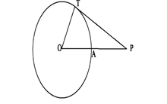

15)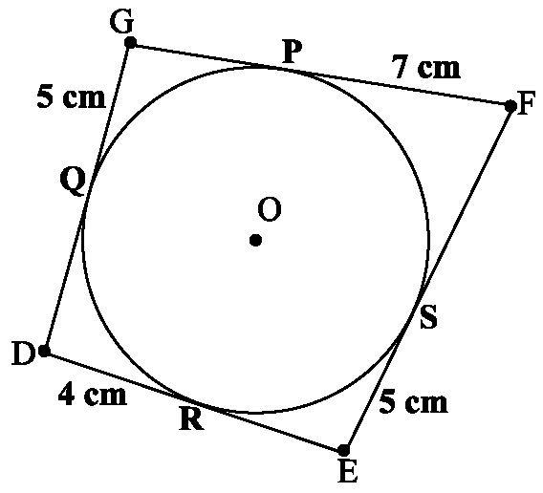 Find the perimeter of DEFG.

16) PA and PB are the two tangents to a circle with centre O in which OP is equal to the diameter of

the circle. Prove that APB is an equilateral triangle.

17) The in circle of ABC touches the sides BC, CA and AB at D, E and F respectively. If AB = AC, prove that

BD = DC.

18) Two tangents PA and PB are drawn to the circle with center O, such that APB = 1200. Prove that OP =

2AP.

19.In the figure, ABC is an isosceles triangle in which AB = AC. A circle through B touches the side AC at D and intersect the side AB at P. If D is the midpoint of side AC, Then AB = 4AP.

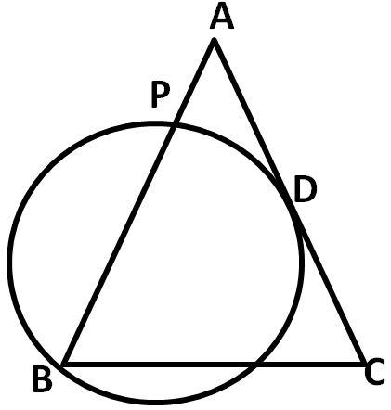

20) 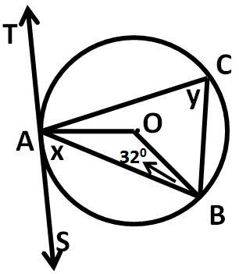In the given figure TAS is a tangent to the circle, with centre O, at the point A. If *OBA* = 320, find the value of x and y.

21. In the given figure. PT is a tangent and PAB is a secant to a circle. If the bisector of <*ATB* intersect AB in M, Prove that: (i) <*PMT = < PTM* (ii) PT = PM

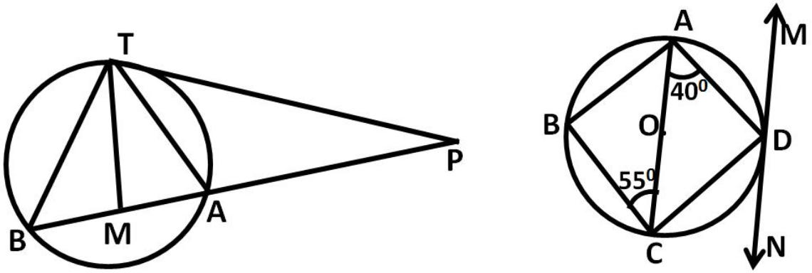

22. In the adjoining figure, ABCD is a cyclic quadrilateral. AC is a diameter of the circle. MN is tangent to the circle at D, <*CAD=*  400 , <*ACB* = 550 Determine <*ADM* and <*BAD*

23.If AB, AC, PQ are tangents in below figure and AB = 5 cm, find the perimeter of APQ.

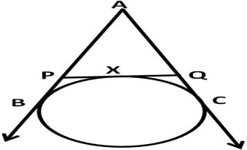

24. If PA and PB are tangents from an outside point P, such that PA = 10 cm and <*APB* = 600 . Find the length of chord AB.

25. From an external point P, tangents PA and PB are drawn to a circle with centre O. If CD is the tangent to the circle at a point E and PA = 14 cm, find the perimeter of PCD.

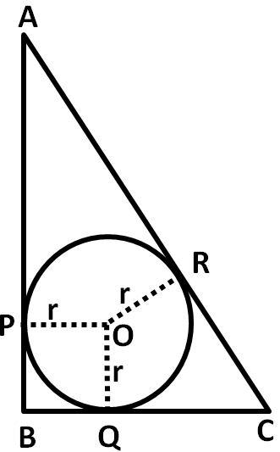From a point P, two tangents PA and PB are drawn to a circle with centre O. If OP = diameter of the circle, show that APB is an equilateral triangle. In fig. ABC is a right triangle right angled at B such that BC = 6 cm and AB = 8 cm. Find the radius of its incircle.

1. In the below figure, ABC is circumscribed, find the value of x

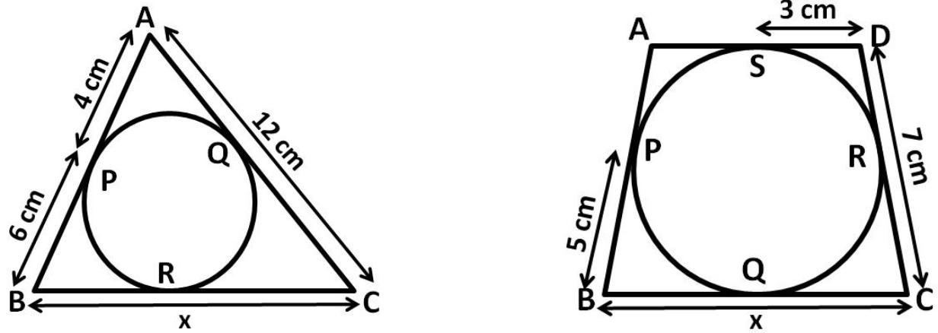

1. In the above right-sided figure, quadrilateral ABCD is circumscribed, find the value of x.
2. A is a point at a distance 13 cm from the centre O of a circle of radius 5 cm. AP and AQ are the tangents to the circle at P and Q. If a tangent BC is drawn at a point R lying on the minor arc PQ to intersect AP at B and AQ at C, find the perimeter of the ABC.
3. 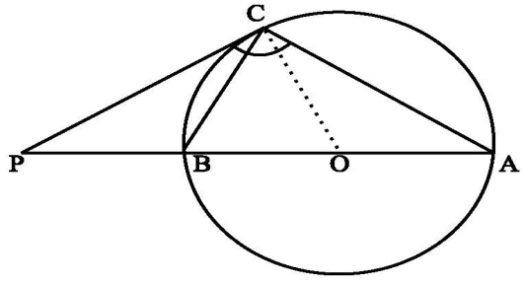The tangent at a point C of a circle and a diameter AB when extended intersect at P. If PCA = 1100, find CBA

1. In a right triangle ABC in which B = 90°, a circle is drawn with AB as diameter intersecting the hypotenuse AC at P. Prove that the tangent to the circle at P bisects BC.
2. AB is a diameter and AC is a chord of a circle with centre O such that BAC = 30°. The tangent at C intersects extended AB at a point D. Prove that BC = BD.
3. 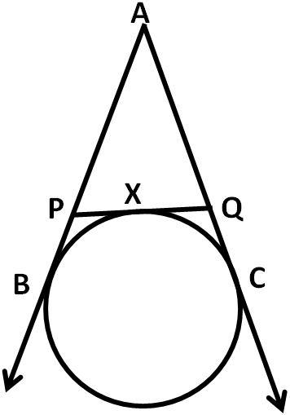In the below figure from an external point A, tangents AB and AC are drawn to a circle. PQ is a tangent to the circle at X. If AC = 15 cm, find the perimeter of the triangle APQ.
4. Prove that the tangents drawn at the ends of a chord of a circle make equal angles with the chord.
5. If PA and PB are two tangents drawn from a point P to a circle with centre O touching it a A and B, prove that OP is the perpendicular bisector of AB.

**Worksheet on Areas Related to Circles**

**_______________________________________________________________________**

1. The area of a circle is 38.5 *cm2*. Find its circumference.
2. The length of a wire is 66 *m* find, how many circles of circumference 1.32 *cm* can be made from this wire?
3. A wheel has diameter 84 *cm*. Find how many complete revolutions must it make to cover 792 *m*.
4. What is the ratio of the areas of a circle and an equilateral triangle whose diameter and a side are respectively equal?
5. The minute hand of a clock is 7 *cm* long. Find the area traced out by the minute hand of the clock between 4.15 pm to 4.35 pm on a day.
6. If the area of semi-circular region is 1,232 *cm2*, find its perimeter.
7. All the four vertices of a rhombus are on a circle. Find the area of the rhombus if the area of the circle is 1256 *cm2*. Use
8. Sides of a triangular field are 15 *m*, 16 *m* and 17 *m*. With the three corners of the field a cow, a buffalo and a horse are tied separately with ropes of length 7*m* each to graze in the field. Find the area of the field which cannot be grazed by three animals.
9. Two circles touch internally. The sum of their areas is 116 $π$*sq.cm* and the distance between their centres is 6 *cm*. Find the radii of the circle.
10. Two circles touch externally. The sum of their areas is 130 $π$*sq.cm* and the distance between their centres is 14 *cm*. Find the radii of the circles.
11. 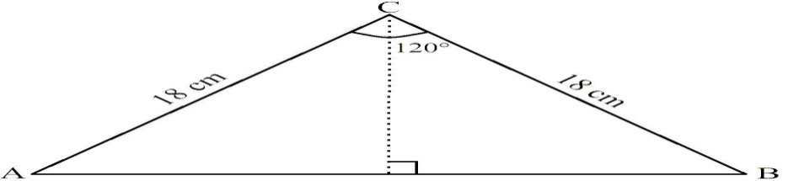Find the area of a $∆$ CAB with ACB = 1200 & CA = CB = 18 *cm*.
12. A lawn is rectangular in the middle and it has semi-circular portions along the shorter sides of the rectangle. The rectangular portion measures 50 *m* by 35 *m*. find the area of the lawn.
13. In the given figure, ABC is right angled at A. Semicircles are drawn on AB, AC and BC as diameters. It is given that AB = 3 *cm* and AC = 4 *cm*. Find the area of the shaded region.
14. 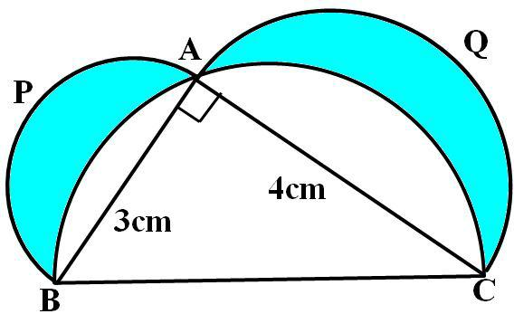
15. With the vertices A, B and C of a triangle ABC as centres, arcs are drawn with radii 5 *cm* each as shown in below figure. If AB = 14 *cm*, BC = 48 *cm* and CA = 50 *cm,* then find the area of the shaded region. (Use = 3.14).
16. 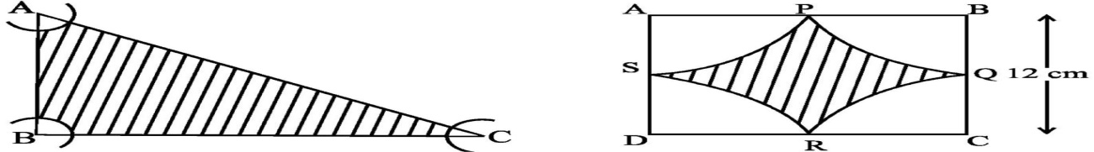
17. Find the area of the shaded region in the above right sided figure, where arcs drawn with centres A, B, C and D intersect in pairs at mid-points P, Q, R and S of the sides AB, BC, CD and DA, respectively of a square ABCD (Use = 3.14).
18. Find the area of the shaded field shown in the below figure.
19. 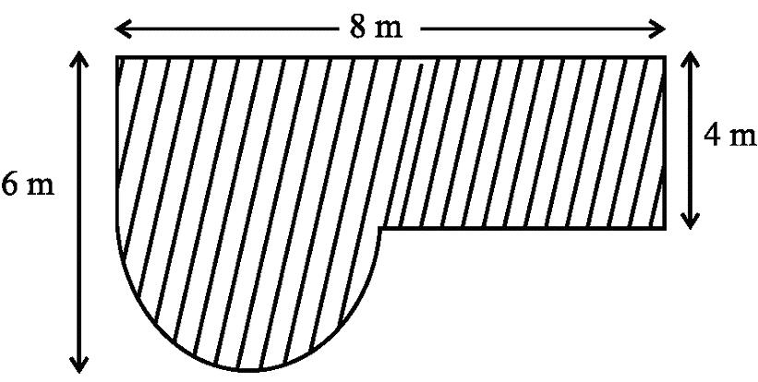
20. An 8 *m* wide circular track is to be made around a circular park of radius 500 *m* at the rate of Rs. 3 per *m2*. Find the width of the track if the total cost is reduced by Rs. 9570.
21. If a chord of a circle of radius r subtends a right angle at the centre of the circle, then show that the area of the corresponding segment of the circle is ( - )r2.
22. The side of a square is 10 *cm*. Find the area between inscribed and circumscribed circle of the square.

**Worksheet on Areas related to Circles**

**_____________________________________________________________________**

1. An iron solid sphere of radius 3 *cm* is melted and recast into small spherical balls of radius 1 *cm* each. Assuming that there is no wastage in the process, find the number of small spherical balls form the given sphere.
2. A conical hole is drilled in a circular cylinder of height 15 *cm* and radius 8 *cm*. The height and base radius of the cone are also the same. Find the total surface area and volume of remaining cylinder.
3. A 20 *m* deep well with diameter 14 *m* is dug and the earth from digging is evenly spread out to form a platform 22 *m* x 14 *m*. Find the height of the platform.
4. A cylinder whose height is equal to its diameter has the same volume as a sphere of radius 4 *cm*. Calculate the radius of the base of the cylinder.
5. A solid metallic sphere of radius 9 *cm* is melted and the material is used to make solid right cones with height 4 *cm* and radius of the base is 9 *cm*. How many cones were made?
6. The height of a cone is 30 *cm*. A small cone is cut off at the top by a plane parallel to the base. If its volume be 1/27 of the volume of the given cone, at what height above the base is the section made?
7. A cylinder and a cone have equal radii of their bases and equal heights. If their curved surface areas are in the ratio 8 : 5, show that the ratio of radius of each to the height of each is 3 : 4.
8. An iron sphere of radius ‘a’ units is immersed completely in water contained in a right circular cone of semi-vertical angle 300, water is drained off from the cone till its surface touches the sphere. Find the volume of water remaining in the cone.
9. A cone of radius 10 *cm* is divided into two parts by drawing a plane through the midpoint of its axis, parallel to its base. Compare the volumes of the two parts and also find the ratio of the volumes of the upper part and the cone.
10. Seven metallic frustum of the same base and top radii 8 *cm* and 4 *cm* respectively and equal height of 7 *cm* are melted and recast into 256 small spheres of equal radii. Find the radius of each sphere.
11. The radii of the bases of two solid right circular cones of same height cones are r1 and r2 respectively. The curves are melted and recast into a cylinder. Find the base-radius of the cylinder.
12. A conical vessel of radius 6 *cm* and height 8 *cm* is completely filled with water. A sphere is lowered into the water and its size is such that when it touches the sides, it is just immersed. What fraction of water overflows?
13. A sphere is placed inside an inverted hollow conical vessel of base radius 5 *cm* and vertical height 12 *cm*. If the highest point of the sphere is at the plane of the base of the cone, find the radius of the sphere. Show that the ratio of the volumes of the sphere and conical vessel is 40 : 81.
14. A sector of a circle of radius 12 *cm* has the angle 1200. It is rolled up so that two bounding radii are joined together to form a cone. Find the volume of the cone.
15. The dimensions of a room are 8 *m* X 6 *m* X h. It has two doors each of size 2 *m* X 1 *m* and one almirah of size 3 *m* X 2 *m*. The cost of covering the walls by wallpaper which is 40 *cm* wide at Rs.1.25 per *m* is Rs. 362.50. Find the height.
16. A cylindrical pipe has inner diameter of 7 *cm* and water flows through it at 192.5 litres per minute. Find the rate of flow in kilometres per hour.
17. A spherical ball of radius 3 *cm* is melted and recast into three spherical balls. If the radii of the two of the balls are 1.5 *cm* and 2 *cm*, then find the diameter of the third ball.
18. A sphere of maximum volume is cut out from a solid hemisphere of radius 7 *cm*. What is the ratio of the volume of the hemisphere to that of the cut out sphere?
19. A hemispherical bowl of internal diameter 36 *cm* contains liquid. This liquid is filled into 72 cylindrical bottles of diameter 6 *cm*. Find the height of the each bottle, if 10% liquid is wasted.
20. A hemispherical tank, of diameter 3 *m*, is full of water. It is being emptied by a pipe at the rate of 3 $\frac{4}{7}$ litre per second. How much time will it take to make the tank half empty? (use $π$ = $\frac{22}{7}$)